Name ______________________________ HOMEWORK 6.3 Feb. 20-24
Put your initials by each night that your child practiced the following:
____Thursday
*Nightly Homework*
- Count numbers 1-75.
- Review Words to Know on the newsletter.

THURSDAY- Blend the sounds together to make a word. Draw a picture of the word you said.

 |  |  | Picture
m | o | p
l | o | g
p | o | t
d | o | t

Say the picture and listen for the consonant blend in the word. Circle the consonant blend in the word.
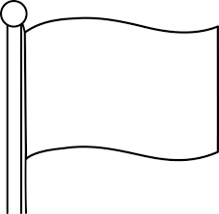  fl cl st | 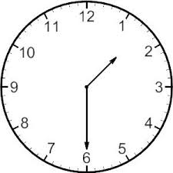  fl cl st | 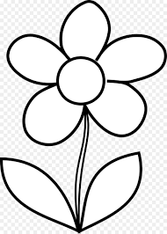  fl cl st | fl cl st | fl cl st

Make a word in the -ake family and draw a picture to go with the word.
___ake | ___ake | ___ake

Read the words.
as our red that find
our red that find as
red that find as our
that find as our red
find as our red find

cub | top | dim | jet | can | web | six
Practice writing each spelling word three times.

Start Right Reader 6.3 Week of February 20-24
Directions: Let your child read this to you.

Words to Know
as our red
that find

Ken and Mel
Ken digs in wet sand. “Can I lend a hand, Ken?” “No, Mel.” Ken fits sand in six red cups. “Ken? Ken?” “Stop it, Mel.” Ken flips six red cups. “Can I do that, Ken?” “Stop it, Mel. No.” The wind tips the sand a bit. But Ken mends it. Ken is fast! “Ken?” “Mel, it is not as good as it can be.” Mel fits a flag on top. “That did it, Mel!” Ken claps.

Blend and Read: Read these words. Find these words in the story.
stop six but
as that red

flag sand stop

